

WAIS®-IV

Wechsler Adult Intelligence Scale®-Fourth Edition

Score Report



|  |  |  |  |  |
| --- | --- | --- | --- | --- |
| Examinee Name | Lily Hancock |  | Date of Report | 01/22/2025 |
| Examinee ID |  |  | Years of Education |  |
| Date of Birth | 09/17/2003 |  | Primary Language |  |
| Gender | Female |  | Handedness |  |
| Race/Ethnicity |  |  | Examiner Name | EDWARDS, WHITNEY |

|  |  |  |  |  |  |  |
| --- | --- | --- | --- | --- | --- | --- |
| Date of Testing | 01/09/2025 |  | Age at Testing | 21 years 3 months |  | Retest? No |

Comments:

|  |
| --- |
| **Composite Score Summary** |

|  |  |  |  |  |  |
| --- | --- | --- | --- | --- | --- |
| **Scale** | **Sum of**  **Scaled Scores** | **Composite**  **Score** | **Percentile**  **Rank** | **95% Conf.**  **Interval** | **Qualitative Description** |

|  |  |  |  |  |  |  |
| --- | --- | --- | --- | --- | --- | --- |
| Verbal Comprehension | 34 | VCI | 107 | 68 | 101-112 | Average |
| Perceptual Reasoning | 39 | PRI | 117 | 87 | 110-122 | High Average |
| Working Memory | 23 | WMI | 108 | 70 | 101-114 | Average |
| Processing Speed | 18 | PSI | 94 | 34 | 86-103 | Average |
| Full Scale | 114 | FSIQ | 109 | 73 | 105-113 | Average |

Confidence Intervals are based on the Overall Average *SEM*s.

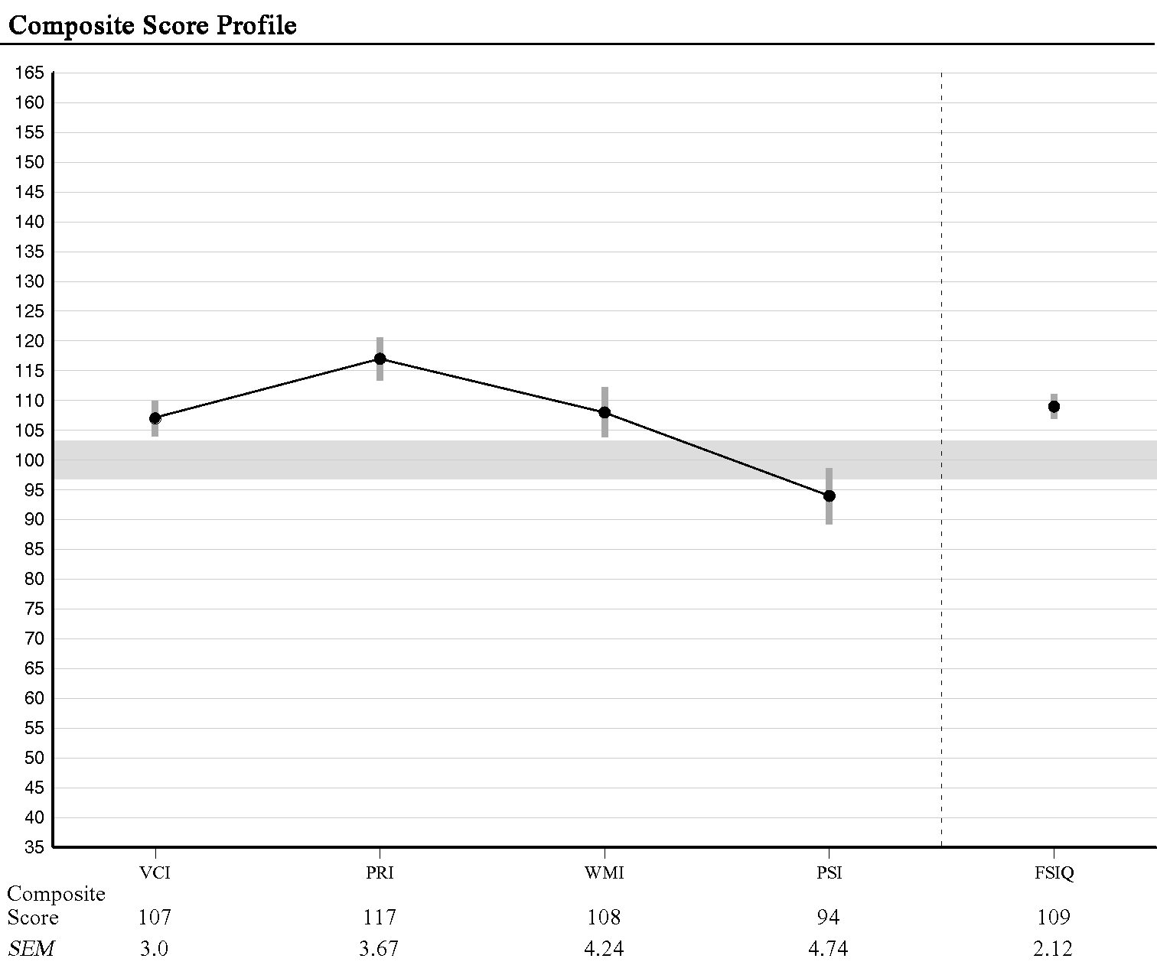

***Note.*** The vertical bars represent the standard error of measurement (*SEM*). *SEM* values are based on the examinee's age.

|  |
| --- |
| **ANALYSIS** |

|  |
| --- |
| **Index Level Discrepancy Comparisons** |

|  |  |  |  |  |  |  |
| --- | --- | --- | --- | --- | --- | --- |
| **Comparison** | **Score 1** | **Score 2** | **Difference** | **Critical Value**  **.05** | **Significant Difference**  **Y/N** | **Base Rate by**  **Overall Sample** |
| VCI - PRI | 107 | 117 | -10 | 9.29 | Y | 22.6 |
| VCI - WMI | 107 | 108 | -1 | 10.18 | N | 48.1 |
| VCI - PSI | 107 | 94 | 13 | 10.99 | Y | 20.3 |
| PRI - WMI | 117 | 108 | 9 | 10.99 | N | 25.7 |
| PRI - PSI | 117 | 94 | 23 | 11.75 | Y | 7.2 |
| WMI - PSI | 108 | 94 | 14 | 12.46 | Y | 18.1 |

Base Rate by Overall Sample.

Statistical significance (critical value) at the .05 level.

|  |
| --- |
| **Verbal Comprehension Subtests Summary** |

|  |  |  |  |  |  |
| --- | --- | --- | --- | --- | --- |
| **Subtest** | **Raw Score** | **Scaled Score** | **Percentile Rank** | **Reference Group Scaled Score** | ***SEM*** |
| Similarities | 26 | 11 | 63 | 10 | 1.16 |
| Vocabulary | 43 | 13 | 84 | 12 | 0.73 |
| Information | 13 | 10 | 50 | 10 | 0.90 |

The scaled scores in the Reference Group Scaled Score column are based on the performance of examinees aged 20:0-34:11 (i.e., the reference group). See Chapter 6 of the WAIS-IV Technical and Interpretive Manual for more information.

|  |
| --- |
| **Perceptual Reasoning Subtests Summary** |

|  |  |  |  |  |  |
| --- | --- | --- | --- | --- | --- |
| **Subtest** | **Raw Score** | **Scaled Score** | **Percentile Rank** | **Reference Group Scaled Score** | ***SEM*** |
| Block Design | 54 | 12 | 75 | 12 | 1.20 |
| Matrix Reasoning | 24 | 14 | 91 | 15 | 1.04 |
| Visual Puzzles | 21 | 13 | 84 | 13 | 0.95 |

|  |
| --- |
| **Working Memory Subtests Summary** |

|  |  |  |  |  |  |
| --- | --- | --- | --- | --- | --- |
| **Subtest** | **Raw Score** | **Scaled Score** | **Percentile Rank** | **Reference Group Scaled Score** | ***SEM*** |
| Digit Span | 27 | 9 | 37 | 9 | 0.90 |
| Arithmetic | 19 | 14 | 91 | 14 | 1.20 |

|  |
| --- |
| **Processing Speed Subtests Summary** |

|  |  |  |  |  |  |
| --- | --- | --- | --- | --- | --- |
| **Subtest** | **Raw Score** | **Scaled Score** | **Percentile Rank** | **Reference Group Scaled Score** | ***SEM*** |
| Symbol Search | 47 | 15 | 95 | 15 | 1.31 |
| Coding | 32 | 3 | 1 | 3 | 1.16 |

|  |
| --- |
| **Subtest Level Discrepancy Comparisons** |

|  |  |  |  |  |  |  |
| --- | --- | --- | --- | --- | --- | --- |
| **Subtest Comparison** | **Score 1** | **Score 2** | **Difference** | **Critical Value**  **.05** | **Significant Difference**  **Y/N** | **Base Rate** |
| Digit Span - Arithmetic | 9 | 14 | -5 | 2.57 | Y | 4.50 |
| Symbol Search - Coding | 15 | 3 | 12 | 3.41 | Y | 0.00 |

Statistical significance (critical value) at the .05 level.

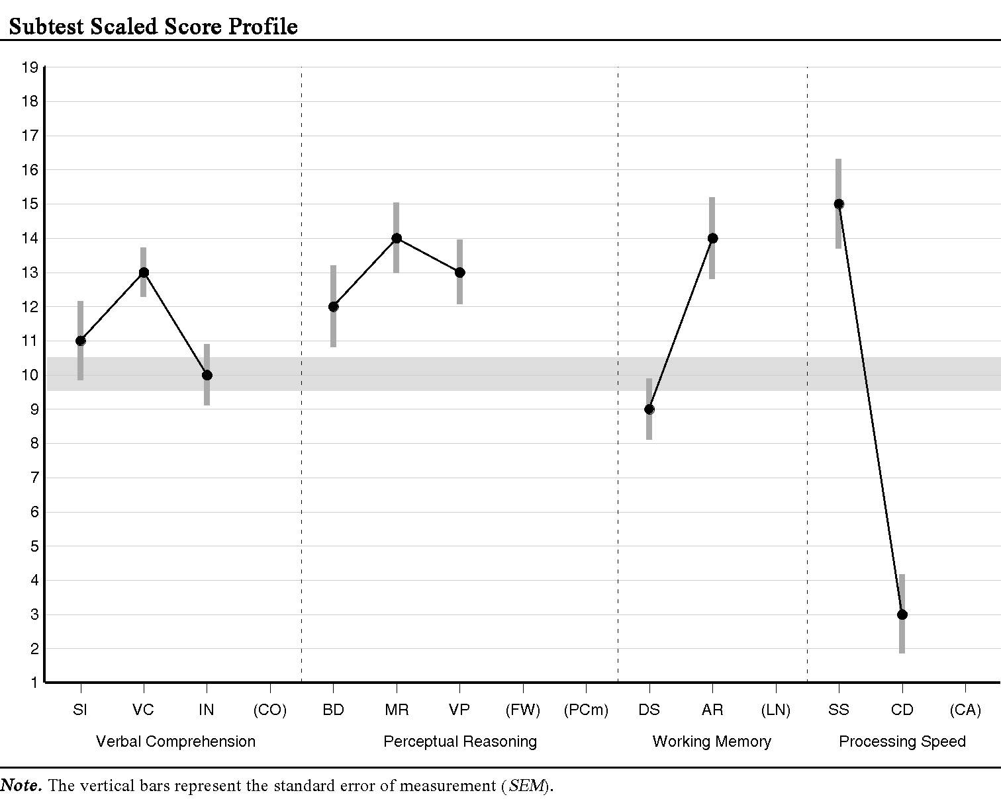

|  |
| --- |
| **DETERMINING STRENGTHS AND WEAKNESSES** |

|  |
| --- |
| **Differences Between Subtest and Overall Mean of Subtest Scores** |

|  |  |  |  |  |  |  |
| --- | --- | --- | --- | --- | --- | --- |
| **Subtest** | **Subtest**  **Scaled Score** | **Mean**  **Scaled Score** | **Difference** | **Critical Value .05** | **Strength or Weakness** | **Base Rate** |
| Block Design | 12 | 11.40 | 0.60 | 2.85 |  | >25% |
| Similarities | 11 | 11.40 | -0.40 | 2.82 |  | >25% |
| Digit Span | 9 | 11.40 | -2.40 | 2.22 | W | 25% |
| Matrix Reasoning | 14 | 11.40 | 2.60 | 2.54 | S | 15-25% |
| Vocabulary | 13 | 11.40 | 1.60 | 2.03 |  | >25% |
| Arithmetic | 14 | 11.40 | 2.60 | 2.73 |  | 15-25% |
| Symbol Search | 15 | 11.40 | 3.60 | 3.42 | S | 10-15% |
| Visual Puzzles | 13 | 11.40 | 1.60 | 2.71 |  | >25% |
| Information | 10 | 11.40 | -1.40 | 2.19 |  | >25% |
| Coding | 3 | 11.40 | -8.40 | 2.97 | W | <1% |

Overall: Mean = 11.40, Scatter = 12, Base rate = 2.0

Base Rate for Intersubtest Scatter is reported for 10 Subtests.

Statistical significance (critical value) at the .05 level.

|  |
| --- |
| **PROCESS ANALYSIS** |

|  |
| --- |
| **Working Memory Process Score Summary** |

|  |  |  |  |  |  |
| --- | --- | --- | --- | --- | --- |
| **Process Score** | **Raw**  **Score** | **Scaled**  **Score** | **Percentile**  **Rank** | **Base Rate** | ***SEM*** |
| Digit Span Forward | 10 | 9 | 37 | -- | 1.34 |
| Digit Span Backward | 9 | 10 | 50 | -- | 1.34 |
| Digit Span Sequencing | 8 | 9 | 37 | -- | 1.27 |

|  |
| --- |
| **Process Level Discrepancy Comparisons** |

|  |  |  |  |  |  |  |
| --- | --- | --- | --- | --- | --- | --- |
| **Process Comparison** | **Score 1** | **Score 2** | **Difference** | **Critical Value**  **.05** | **Significant Difference**  **Y/N** | **Base Rate** |
| Digit Span Forward -  Digit Span Backward | 9 | 10 | -1 | 3.65 | N | 46.8 |
| Digit Span Forward -  Digit Span Sequencing | 9 | 9 | 0 | 3.60 | N |  |
| Digit Span Backward -  Digit Span Sequencing | 10 | 9 | 1 | 3.56 | N | 43.0 |

Statistical significance (critical value) at the .05 level.

**End of Report**