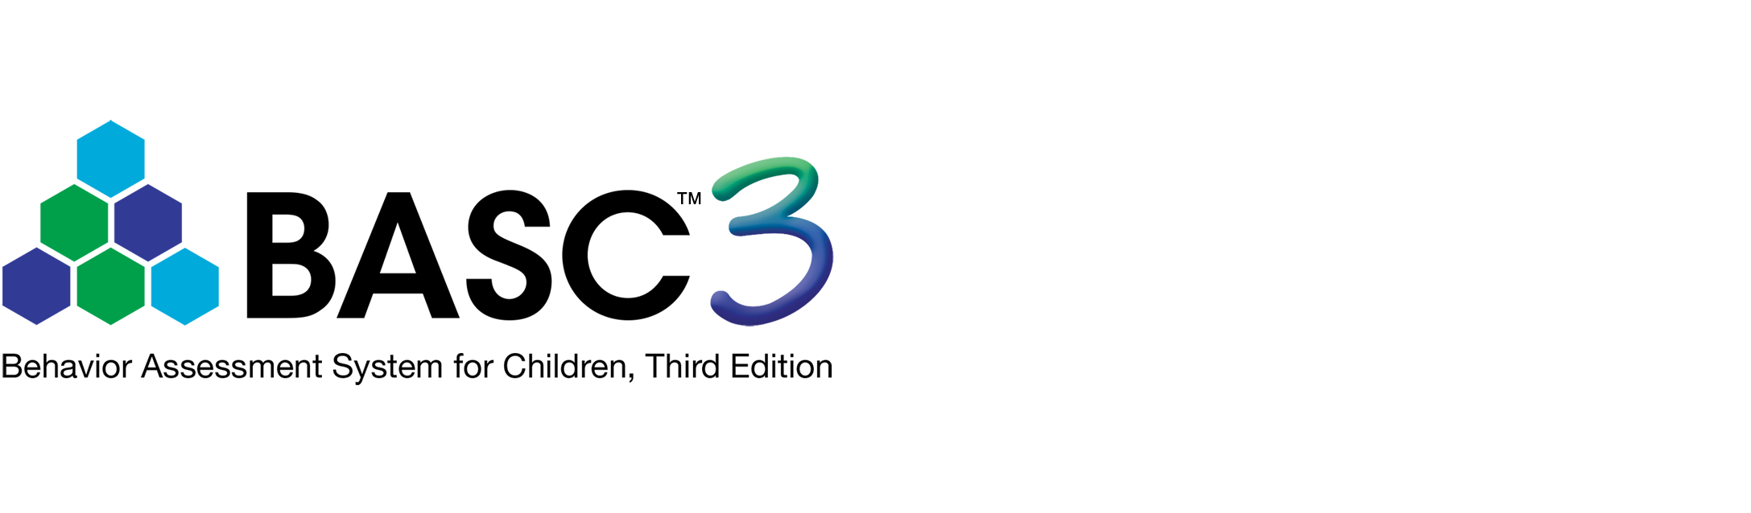

Behavior Assessment System for Children, Third Edition (BASC™-3)

BASC-3 Self-Report of Personality - College

Interpretive Summary Report

*Cecil R. Reynolds, PhD, & Randy W. Kamphaus, PhD*



|  |  |  |  |
| --- | --- | --- | --- |
|  | **Child Information** |  | **Test Information** |
| ID: |  | Test Date: | 12/05/2024 |
| Name: | Lily Hancock | Rater Name: | Self |
| Gender: | Female |  |  |
| Birth Date: | 09/17/2003 |  |  |
| Age: | 21:2 |  |  |
| Year in School: |  |  |  |
| School: |  |  |  |
| Enrollment: |  |  |  |

Norm Group 1: General Combined

**COMMENTS AND CONCERNS**

No comments or concerns were provided.

**VALIDITY INDEX SUMMARY**

|  |  |  |  |  |
| --- | --- | --- | --- | --- |
| ***F* Index** | **Response Pattern** | **Consistency** | ***L* Index** | ***V* Index** |
| Acceptable | Acceptable | Acceptable | Acceptable | Acceptable |
| Raw Score: 0 | Raw Score: 117 | Raw Score: 11 | Raw Score: 1 | Raw Score: 0 |

**CLINICAL AND ADAPTIVE *T*-SCORE PROFILE**

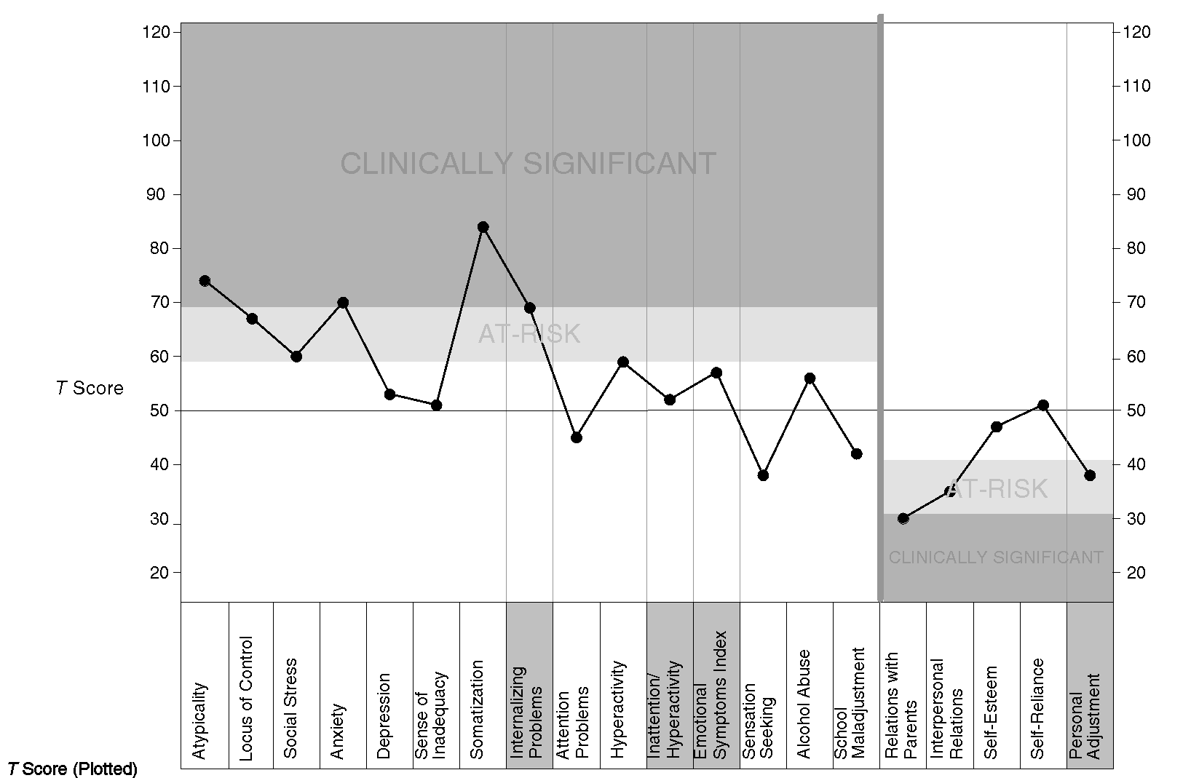

|  |  |  |  |  |  |  |  |  |  |  |  |  |  |  |  |  |  |  |  |  |
| --- | --- | --- | --- | --- | --- | --- | --- | --- | --- | --- | --- | --- | --- | --- | --- | --- | --- | --- | --- | --- |
| l General Combined | 74 | 67 | 60 | 70 | 53 | 51 | 84 | 69 | 45 | 59 | 52 | 57 | 38 | 56 | 42 | 30 | 35 | 47 | 51 | 38 |
|  |  |  |  |  |  |  |  |  |  |  |  |  |  |  |  |  |  |  |  |  |
| **Percentile** |  |  |  |  |  |  |  |  |  |  |  |  |  |  |  |  |  |  |  |  |
| General Combined | 96 | 92 | 84 | 96 | 74 | 64 | 99 | 94 | 40 | 83 | 65 | 79 | 11 | 82 | 24 | 5 | 9 | 30 | 50 | 14 |

**CLINICAL AND ADAPTIVE SCORE TABLE: General Combined Norm Group**

**Composite Score Summary**

|  |  |  |  |  |
| --- | --- | --- | --- | --- |
|  | **Raw Score** | ***T* Score** | **Percentile Rank** | **90% Confidence Interval** |
| Internalizing Problems | 459 | 69 | 94 | 66-72 |
| Inattention/Hyperactivity | 104 | 52 | 65 | 47-57 |
| Emotional Symptoms Index | 336 | 57 | 79 | 54-60 |
| Personal Adjustment | 163 | 38 | 14 | 34-42 |

|  |  |  |  |
| --- | --- | --- | --- |
| **Composite Comparisons** | **Difference** | **Significance Level** | **Frequency of Difference** |
| Internalizing Problems vs. Inattention/Hyperactivity | 17 | 0.01 | 10% or less |

|  |  |
| --- | --- |
| **Mean *T* score of the ESI** | **56** |
| **Inverted Mean *T* score of the ESI** | **44** |

**Scale Score Summary**

|  |  |  |  |  |  |
| --- | --- | --- | --- | --- | --- |
|  |  |  |  |  | **Ipsative Comparison** |

|  |  |  |  |  |  |  |  |
| --- | --- | --- | --- | --- | --- | --- | --- |
|  | **Raw Score** | ***T* Score** | **Percentile Rank** | **90% Confidence Interval** | **Difference** | **Significance Level** | **Frequency of Difference** |
| Atypicality | 13 | 74 | 96 | 67-81 | 18 | 0.05 | 5% or less |
| Locus of Control | 12 | 67 | 92 | 60-74 | 11 | NS |  |
| Social Stress | 13 | 60 | 84 | 54-66 | 4 | NS |  |
| Anxiety | 28 | 70 | 96 | 65-75 | 14 | 0.05 | 5% or less |
| Depression | 6 | 53 | 74 | 47-59 | -3 | NS |  |
| Sense of Inadequacy | 7 | 51 | 64 | 45-57 | -5 | NS |  |
| Somatization | 12 | 84 | 99 | 76-92 | 28 | 0.05 | 2% or less |
| Attention Problems | 6 | 45 | 40 | 39-51 | -11 | NS |  |
| Hyperactivity | 9 | 59 | 83 | 52-66 | 3 | NS |  |
| Sensation Seeking | 4 | 38 | 11 | 32-44 | -18 | 0.05 | 25% or less |
| Alcohol Abuse | 8 | 56 | 82 | 52-60 | 0 | NS |  |
| School Maladjustment | 4 | 42 | 24 | 35-49 | -14 | 0.05 | 10% or less |
| Relations with Parents | 12 | 30 | 5 | 25-35 | -14 | 0.05 | 15% or less |
| Interpersonal Relations | 11 | 35 | 9 | 28-42 | -9 | NS |  |
| Self-Esteem | 12 | 47 | 30 | 41-53 | 3 | NS |  |
| Self-Reliance | 17 | 51 | 50 | 43-59 | 7 | NS |  |

Note: All classifications of test scores are subject to the application of the standard error of measurement (SEM) when making classification decisions. Individual clinicians are advised to consider all case-related information to determine if a particular classification is appropriate. See the BASC-3 Manual for additional information on SEMs and confidence intervals.

**CLINICAL VALIDITY INDEX NARRATIVES**

The *V* Index consists of nonsensical or extremely improbable items that typically are only marked by examinees due to carelessness, a failure to understand the questions, or a failure to cooperate with the assessment process.

Lily obtained a *V* Index score that falls within the **Acceptable** range, providing some indication that she understood the items and responded to them in accordance with the instructions provided on the test form.

The Consistency Index identifies situations when the examinee has given inconsistent responses to items that are typically answered in a similar way, based on comparisons made to examinees from the general population. The Consistency Index was designed to identify ratings that might not be easily interpretable due to these response discrepancies.

Lily's Consistency Index score falls within the **Acceptable** range, providing some support the child understood the rating form items and was attentive when providing responses to each item.

The BASC-3 *F* Index is a classically derived infrequency scale, designed to assess the possibility that a respondent depicted themself in an inordinately negative fashion. The *F* Index consists of items that represent maladaptive behaviors to which the respondent answered "almost always" or "true" and adaptive behaviors to which the respondent answered "never" or "false." The *F* Index score based on Lily's ratings falls within the **Acceptable** range and does not indicate the presence of any form of negative response distortion.

The SRP *L* Index is designed to detect a response set that may be characterized as one of social desirability or "faking good." In general, it is composed of items that represent behaviors that children engage in at least some of the time. Lily's responses to the *L* Index items resulted in a score within the **Acceptable** range, indicating that she may not have attempted to present herself in a positive light.

**VALIDITY INDEX ITEM LISTS**

Validity Index ratings for *F* Index, Response Pattern Index, and Consistency Index are all Acceptable.

***F* Index**

The *F* Index rating is Acceptable.

**Response Pattern Index**

The Response Pattern Index rating is Acceptable.

**Consistency Index**

The Consistency Index rating is Acceptable.

***L* Index**

The *L* Index rating is Acceptable.

***V* Index**

The *V* Index rating is Acceptable.

**CLINICAL AND ADAPTIVE SCALE NARRATIVES**

This report is based on Lily's rating of herself using the BASC-3 Self-Report of Personality form. The narrative and scale classifications in this report are based on *T* scores obtained using norms. Scale scores in the Clinically Significant range suggest a high level of maladjustment. Scores in the At-Risk range may identify a significant problem that may not be severe enough to require formal treatment or may identify the potential of developing a problem that needs careful monitoring.

**Internalizing Problems**

The Internalizing Problems composite scale *T* score is 69, with a 90% confidence interval range of 66-72 and a percentile rank of 94. Lily's *T* score on this composite scale falls in the At-Risk classification range.

Lily's *T* score on Atypicality is 74 and has a percentile rank of 96. This *T* score falls in the Clinically Significant classification range and usually warrants follow-up. Lily reports having a number of unusual thoughts and perceptions.

Lily's *T* score on Locus of Control is 67 and has a percentile rank of 92. This *T* score falls in the At-Risk classification range and follow-up may be necessary. Lily reports sometimes having little control over events occurring in her life and reports sometimes being blamed for things that she did not do.

Lily's *T* score on Social Stress is 60 and has a percentile rank of 84. This *T* score falls in the At-Risk classification range and follow-up may be necessary. Lily reports some difficulty with establishing and maintaining close relationships with others and reports sometimes being isolated and lonely.

Lily's *T* score on Anxiety is 70 and has a percentile rank of 96. This *T* score falls in the Clinically Significant classification range and usually warrants follow-up. Lily reports excessive worrying, nervousness, and/or an inability to relax.

Lily's *T* score on Depression is 53 and has a percentile rank of 74. Lily reports depressed feelings no more often than others of the same age.

Lily's *T* score on Sense of Inadequacy is 51 and has a percentile rank of 64. Lily reports feelings of inadequacy no more often than others of the same age.

Lily's *T* score on Somatization is 84 and has a percentile rank of 99. This *T* score falls in the Clinically Significant classification range and usually warrants follow-up. Lily reports experiencing numerous health-related problems that may include headaches, sore muscles, stomach ailments, and/or dizziness.

**Inattention/Hyperactivity**

The Inattention/Hyperactivity composite scale *T* score is 52, with a 90% confidence interval range of 47-57 and a percentile rank of 65.

Lily's *T* score on Attention Problems is 45 and has a percentile rank of 40. Lily reports maintaining an attention level similar to that of others of the same age.

Lily's *T* score on Hyperactivity is 59 and has a percentile rank of 83. Lily reports maintaining a level of self-control that is similar to the levels displayed by others of the same age.

**Emotional Symptoms Index**

The Emotional Symptoms Index composite scale *T* score is 57, with a 90% confidence interval range of 54-60 and a percentile rank of 79.

**Personal Adjustment**

The Personal Adjustment composite scale *T* score is 38, with a 90% confidence interval range of 34-42 and a percentile rank of 14. Lily's *T* score on this composite scale falls in the At-Risk classification range.

Lily's *T* score on Relations With Parents is 30 and has a percentile rank of 5. This *T* score falls in the Clinically Significant classification range and usually warrants follow-up. Lily reports having a poor relationship with her parents. Lily may report having little trust in her parents and may feel incidental to family life and decision-making.

Lily's *T* score on Interpersonal Relations is 35 and has a percentile rank of 9. This *T* score falls in the At-Risk classification range and follow-up may be necessary. Lily reports having difficulty establishing and maintaining relationships with others.

Lily's *T* score on Self-Esteem is 47 and has a percentile rank of 30. Lily reports a self-image that is similar to others of the same age.

Lily's *T* score on Self-Reliance is 51 and has a percentile rank of 50. Lily reports having about as much confidence as others of the same age in her ability to make decisions, solve problems, and/or be dependable.

**Additional Scales**

Lily's *T* score on Sensation Seeking is 38 and has a percentile rank of 11. Lily reports engaging in risky behaviors slightly less often as others of the same age.

Lily's *T* score on Alcohol Abuse is 56 and has a percentile rank of 82. Lily reports using alcohol for reasons that are typical of others of the same age.

Lily's *T* score on School Maladjustment is 42 and has a percentile rank of 24. Lily reports typical levels of distress associated with attending postsecondary schools compared to others of the same age.

**CONTENT SCALE AND INDEX *T*-SCORE PROFILE**

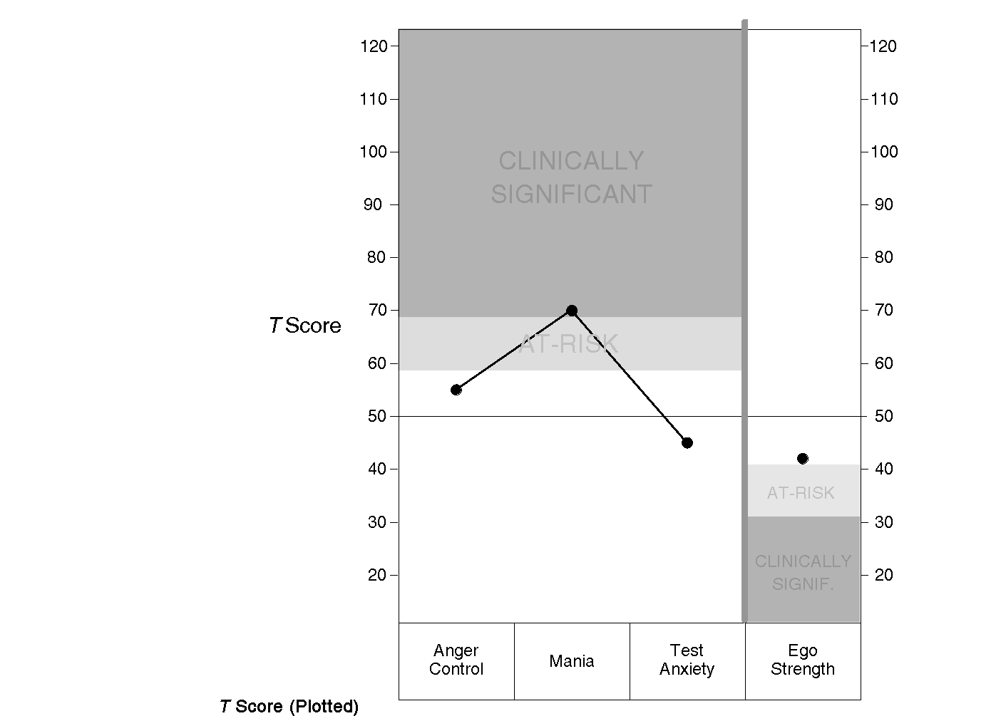

|  |  |  |  |  |
| --- | --- | --- | --- | --- |
| l General Combined | 55 | 70 | 45 | 42 |
|  |  |  |  |  |
| **Percentile** |  |  |  |  |
| General Combined | 76 | 96 | 36 | 19 |

**CONTENT SCALE SCORE TABLE: General Combined Norm Group**

|  |  |  |  |  |
| --- | --- | --- | --- | --- |
|  | **Raw Score** | ***T* Score** | **Percentile Rank** | **90% Confidence Interval** |
| Test Anxiety | 7 | 45 | 36 | 38-52 |
| Anger Control | 8 | 55 | 76 | 48-62 |
| Mania | 21 | 70 | 96 | 64-76 |
| Ego Strength | 15 | 42 | 19 | 34-50 |

**Content Scale Narratives**

Lily's *T* score on Test Anxiety is 45 and has a percentile rank of 36. Lily reports experiencing test-related anxiety no more often than others of the same age.

Lily's *T* score on Anger Control is 55 and has a percentile rank of 76. Lily reports responding to adversity in a manner that is typical of others of the same age.

Lily's *T* score on Mania is 70 and has a percentile rank of 96. This *T* score falls in the Clinically Significant classification range and usually warrants follow-up. Lily reports having extended periods of heightened arousal and difficulty relaxing.

Lily's *T* score on Ego Strength is 42 and has a percentile rank of 19. Lily reports a level of self-identify and emotional competence that is typical of others of the same age.

***DSM-5*™ DIAGNOSTIC CRITERIA**

Listed below are *DSM-5* Diagnostic Criteria based on the ratings obtained from the individual on the SRP-College rating form. Each section first presents a list of symptoms of the disorder, along with SRP-College items that correspond to these symptoms. Then related *DSM-5* criteria and codes are presented. While information from SRP-College items will likely be helpful for making a diagnosis, clinicians are strongly encouraged to use additional information that is gathered outside of the BASC-3 SRP-College form (e.g., observations of behavior, clinical interviews) when making a formal diagnosis. Reprinted with permission from the *Diagnostic and Statistical Manual of Mental Disorders,* Fifth Edition (Copyright © 2013).

**Generalized Anxiety Disorder**

List of Symptoms

|  |  |
| --- | --- |
| *Area 1: Presence of Significant Worry/Anxiety* | *Relevant BASC-3 SRP-College Items and the individual's Responses* |

|  |  |  |
| --- | --- | --- |
| X | Difficult to control, excessive anxiety and worry about a number of events/activities | 40. I often worry about something bad happening to me. (True)  125. I worry but I don't know why. (Almost always)  160. I worry when I go to bed at night. (Sometimes)  177. I worry about what is going to happen. (Almost always) |

|  |  |
| --- | --- |
| *Area 2: Symptoms Associated With Worry/Anxiety* |  |

|  |  |  |
| --- | --- | --- |
| X | Feels restless, keyed up, or on edge | 14. I can never seem to relax. (True)  75. I have a hard time slowing down. (Almost always)  119. I get nervous. (Almost always)  151. I can't seem to turn off my mind. (Almost always)  183. I get nervous when things do not go the right way for me. (Almost always) |
| __ | Tires easily |  |
| __ | Has trouble concentrating or mind goes blank |  |
| __ | Is irritable |  |
| __ | Experiences muscle tension |  |
| __ | Has trouble sleeping |  |

*DSM-5* Codes and Diagnostic Criteria

**Generalized Anxiety Disorder 300.02 (F41.1)**

See the Q-global Resource Library for a reprint of the *DSM-5* Diagnostic Criteria for Generalized Anxiety Disorder.

**Manic Episode**

List of Symptoms

|  |  |
| --- | --- |
| *Presence of Elevated or Irritable Mood* | *Relevant BASC-3 SRP-College Items and the individual's Responses* |

|  |  |  |
| --- | --- | --- |
| __ | Elevated, expansive, or irritable mood |  |
| X | Abnormally increased goal-directed activity or energy | 75. I have a hard time slowing down. (Almost always) |

|  |  |
| --- | --- |
| *Symptoms Present With Mood Changes* |  |

|  |  |  |
| --- | --- | --- |
| __ | Decreased need for sleep | 117. I stay awake for 24 hours without getting tired. (Never) |
| X | More talkative than usual | 95. When I start talking, it is hard for me to stop. (Often) |
| X | Racing thoughts or flight of ideas | 139. Ideas just race through my mind. (Often)  151. I can't seem to turn off my mind. (Almost always) |
| __ | Inflated self-esteem or grandiosity |  |
| __ | Distractibility |  |
| __ | Increased goal-directed activity |  |
| __ | Excessive involvement in high-risk activities |  |

*DSM-5* Codes and Diagnostic Criteria

Note: No *DSM-5* codes are applicable to Manic Episode.

***DSM-5*™ DIAGNOSTIC CONSIDERATIONS**

The BASC-3 SRP-College contains items related to a number of *DSM-5* criteria for the diagnosis of disorders. Listed below are ALL items related to *DSM-5* criteria regardless of their responses. While information from SRP-College items will likely be helpful for making a diagnosis, clinicians are strongly encouraged to use additional information that is gathered outside of the BASC-3 SRP-College form (e.g., observations of behavior, clinical interviews) when making a formal diagnosis.

**Generalized Anxiety Disorder 300.02 (F41.1)**

Related BASC-3 items:

14. I can never seem to relax. (True)

40. I often worry about something bad happening to me. (True)

75. I have a hard time slowing down. (Almost always)

119. I get nervous. (Almost always)

125. I worry but I don't know why. (Almost always)

151. I can't seem to turn off my mind. (Almost always)

160. I worry when I go to bed at night. (Sometimes)

177. I worry about what is going to happen. (Almost always)

183. I get nervous when things do not go the right way for me. (Almost always)

**Manic Episode**

Related BASC-3 items:

75. I have a hard time slowing down. (Almost always)

95. When I start talking, it is hard for me to stop. (Often)

117. I stay awake for 24 hours without getting tired. (Never)

139. Ideas just race through my mind. (Often)

151. I can't seem to turn off my mind. (Almost always)

**CRITICAL ITEMS**

Bolded items may be of particular interest.

42. I never seem to get anything right. (False)

43. I just don't care anymore. (False)

**65. I drink alcohol to feel better. (Sometimes)**

**83. My life seems out of my control. (Sometimes)**

92. Someone wants to hurt me. (Never)

**96. I feel sad. (Often)**

**116. I feel life isn't worth living. (Sometimes)**

**124. I have trouble controlling my thoughts. (Almost always)**

142. I feel like quitting school. (Never)

150. I hear voices in my head that no one else can hear. (Never)

158. I feel like my life is getting worse and worse. (Never)

167. No one understands me. (Never)

192. I miss classes because of drinking or having a hangover. (Never)

**ITEMS BY SCALE - CLINICAL SCALES**

**Anxiety**

14. I can never seem to relax. (True)

26. I worry a lot of the time. (True)

40. I often worry about something bad happening to me. (True)

58. I feel guilty about things. (Often)

62. Little things bother me. (Often)

98. I feel stressed. (Often)

119. I get nervous. (Almost always)

125. I worry but I don't know why. (Almost always)

136. I get so nervous I can't breathe. (Sometimes)

156. I feel anxious. (Often)

160. I worry when I go to bed at night. (Sometimes)

177. I worry about what is going to happen. (Almost always)

183. I get nervous when things do not go the right way for me. (Almost always)

**Attention Problems**

9. People tell me I should pay more attention. (False)

19. I think that I have a short attention span. (True)

38. I have attention problems. (False)

81. I am easily distracted. (Sometimes)

115. I forget to do things. (Never)

127. I have a hard time concentrating. (Sometimes)

148. I get into trouble for not paying attention. (Never)

164. I have trouble paying attention to lectures. (Sometimes)

187. I have trouble paying attention to what I am doing. (Sometimes)

**Atypicality**

15. Sometimes, when alone, I hear my name. (True)

68. I feel like people are out to get me. (Often)

73. I hear things that others cannot hear. (Sometimes)

92. Someone wants to hurt me. (Never)

104. People think I'm strange. (Sometimes)

124. I have trouble controlling my thoughts. (Almost always)

134. I see weird things. (Sometimes)

150. I hear voices in my head that no one else can hear. (Never)

165. I do things over and over and can't stop. (Often)

172. Even when alone, I feel like someone is watching me. (Sometimes)

**Depression**

6. I don't seem to do anything right. (False)

22. Nothing about me is right. (False)

34. Nothing feels good to me. (False)

43. I just don't care anymore. (False)

49. Nothing ever goes right for me. (False)

82. I feel lonely. (Often)

96. I feel sad. (Often)

116. I feel life isn't worth living. (Sometimes)

141. I feel depressed. (Sometimes)

158. I feel like my life is getting worse and worse. (Never)

167. No one understands me. (Never)

185. I feel like I have no friends. (Never)

**Hyperactivity**

67. I have trouble standing still in lines. (Often)

77. People tell me that I am too noisy. (Sometimes)

90. People tell me to slow down. (Sometimes)

109. I have trouble sitting still. (Often)

146. People tell me to be still. (Sometimes)

168. I feel like I have to get up and move around. (Sometimes)

179. I talk while other people are talking. (Sometimes)

**Locus of Control**

4. What I want never seems to matter. (False)

30. I can never really do what I want to do. (False)

37. Things go wrong for me, even when I try hard. (True)

50. I never really feel in control of my life. (True)

83. My life seems out of my control. (Sometimes)

97. My parents expect too much from me. (Almost always)

137. I get blamed for things I can't help. (Often)

147. I am blamed for things I don't do. (Sometimes)

169. People get mad at me, even when I don't do anything wrong. (Sometimes)

**Sensation Seeking**

18. I like to stretch the rules. (False)

39. I am more daring than my friends are. (False)

47. I like to take chances. (False)

70. I like it when my friends dare me to do something. (Never)

101. I like to ride in a car that is going fast. (Sometimes)

112. I like to be the first one to try new things. (Sometimes)

126. I like to take risks. (Never)

143. I like to experiment with new things. (Sometimes)

152. I do things that my friends are afraid to do. (Sometimes)

171. I like to dare others to do things. (Never)

184. I find dangerous things exciting. (Never)

**Sense of Inadequacy**

27. Doing my best is never good enough. (False)

33. Most things are harder for me than for others. (True)

42. I never seem to get anything right. (False)

52. I never quite reach my goal. (False)

66. When I take tests, I can't think. (Sometimes)

105. I want to do better, but I can't. (Sometimes)

122. I fail at things. (Sometimes)

129. I am disappointed with my grades. (Never)

155. People tell me to try harder. (Never)

176. Even when I try hard, I fail. (Sometimes)

180. I quit easily. (Sometimes)

**Social Stress**

3. My friends have more fun than I do. (False)

11. I don't feel comfortable around other people. (True)

31. Other people are happier than I am. (True)

48. I don't know how to act around others. (False)

84. I am left out of things. (Never)

102. Other people seem to ignore me. (Often)

113. I am lonely. (Sometimes)

132. People act as if they don't hear me. (Sometimes)

159. I feel out of place around people. (Often)

166. Other people find things wrong with me. (Sometimes)

190. I feel that others do not like the way I do things. (Often)

**Somatization**

16. I get sick more than others. (True)

24. Often I feel sick in my stomach. (True)

35. It seems like I'm always sick. (True)

53. My stomach gets upset more than most people's. (True)

88. I have trouble breathing. (Often)

106. I am in pain. (Sometimes)

163. I feel dizzy. (Sometimes)

**Alcohol Abuse**

21. I get into trouble because of my drinking. (False)

65. I drink alcohol to feel better. (Sometimes)

74. I drink alcohol to calm down. (Sometimes)

79. I drink alcohol when I am by myself. (Never)

91. I drink alcohol when I am bored. (Never)

94. Drinking alcohol helps me cope with my problems. (Sometimes)

103. I feel better after a couple of drinks of alcohol. (Sometimes)

118. I drink alcohol so I can be at ease around others or at a party. (Often)

123. I drink more alcohol than I plan to drink. (Never)

130. People tell me I drink alcohol too much (Never)

138. I do embarrassing things when I drink too much alcohol. (Sometimes)

144. I think about when I can go drinking again. (Sometimes)

149. I need alcoholic beverages to have a good time. (Never)

192. I miss classes because of drinking or having a hangover. (Never)

**School Maladjustment**

2. I am bored with school. (False)

13. I am tired of going to school. (False)

28. I never seem to feel like working on school assignments. (False)

44. I think that I am going to school for the wrong reasons. (False)

51. My parents are pressuring me to go to school. (False)

72. I enjoy doing schoolwork. (Sometimes)

89. I feel like I belong at my school. (Often)

99. I wonder why I am going to school. (Never)

110. I feel overwhelmed by the demands of school. (Sometimes)

142. I feel like quitting school. (Never)

170. I worry about being able to complete my school degree. (Never)

**ITEMS BY SCALE - ADAPTIVE SCALES**

**Interpersonal Relations**

8. I have a hard time making friends. (False)

46. Other people don't like me. (True)

71. I enjoy meeting others. (Sometimes)

120. I am liked by others. (Often)

128. I feel that nobody likes me. (Sometimes)

157. I get along well with others. (Sometimes)

173. People think I am fun to be with. (Sometimes)

189. Others have respect for me. (Often)

**Relations with Parents**

20. I get along well with my parents. (False)

64. My parents are proud of me. (Almost always)

69. My mother and father like my friends. (Sometimes)

78. I like going places with my parents. (Never)

87. My parents trust me. (Almost always)

93. My parents are easy to talk to. (Sometimes)

111. I like my parents. (Sometimes)

121. My mother and father help me if I ask them to. (Sometimes)

133. My parents like to be with me. (Sometimes)

153. I am proud of my parents. (Never)

178. My parents listen to what I say. (Sometimes)

**Self-Esteem**

1. I like who I am. (True)

7. I feel good about myself. (True)

55. I wish I were different. (False)

60. I have confidence in myself. (Sometimes)

100. I like the way I look. (Often)

174. My looks bother me. (Sometimes)

188. I'm happy with who I am. (Sometimes)

**Self-Reliance**

10. If I have a problem, I can usually work it out. (True)

61. I am dependable. (Almost always)

76. I can solve difficult problems by myself. (Sometimes)

107. I am reliable. (Almost always)

131. My friends come to me for help. (Sometimes)

161. I am someone you can rely on. (Almost always)

182. I am good at making decisions. (Often)

191. Others ask me to help them. (Often)

**ITEMS BY SCALE - CONTENT SCALES**

**Anger Control**

59. When I get angry, I want to break something. (Sometimes)

62. Little things bother me. (Often)

63. I get angry easily. (Sometimes)

68. I feel like people are out to get me. (Often)

135. I threaten to hurt others when I get angry. (Never)

147. I am blamed for things I don't do. (Sometimes)

162. I yell when I get angry. (Never)

169. People get mad at me, even when I don't do anything wrong. (Sometimes)

175. When I get angry, I want to hurt someone. (Never)

**Ego Strength**

1. I like who I am. (True)

29. I accept myself for who I am. (False)

60. I have confidence in myself. (Sometimes)

87. My parents trust me. (Almost always)

120. I am liked by others. (Often)

140. I'm a good person. (Almost always)

158. I feel like my life is getting worse and worse. (Never)

188. I'm happy with who I am. (Sometimes)

**Mania**

75. I have a hard time slowing down. (Almost always)

83. My life seems out of my control. (Sometimes)

95. When I start talking, it is hard for me to stop. (Often)

108. My thoughts keep me awake at night. (Often)

109. I have trouble sitting still. (Often)

117. I stay awake for 24 hours without getting tired. (Never)

124. I have trouble controlling my thoughts. (Almost always)

139. Ideas just race through my mind. (Often)

151. I can't seem to turn off my mind. (Almost always)

165. I do things over and over and can't stop. (Often)

168. I feel like I have to get up and move around. (Sometimes)

**Test Anxiety**

23. No matter how much I study for a test, I am afraid I will fail. (False)

54. I hate taking tests. (False)

66. When I take tests, I can't think. (Sometimes)

80. Tests make me nervous. (Often)

85. I get upset when I have to take a test. (Sometimes)

110. I feel overwhelmed by the demands of school. (Sometimes)

114. I have trouble sleeping the night before a big test (Sometimes)

129. I am disappointed with my grades. (Never)

145. I do well on tests. (Often)

*The Behavior Assessment System for Children, Third Edition (BASC-3) is an integrated system designed to facilitate the differential diagnosis and classification of a variety of emotional and behavioral disorders of children and to aid in the design of treatment plans. This computer-generated report should not be the sole basis for making important diagnostic or treatment decisions.*

**End of Report**

**ITEM RESPONSES**

|  |  |  |  |  |  |  |  |  |  |  |  |  |  |  |  |  |  |  |  |
| --- | --- | --- | --- | --- | --- | --- | --- | --- | --- | --- | --- | --- | --- | --- | --- | --- | --- | --- | --- |
| 1: | 1 | 2: | 2 | 3: | 2 | 4: | 2 | 5: | 2 | 6: | 2 | 7: | 1 | 8: | 2 | 9: | 2 | 10: | 1 |
| 11: | 1 | 12: | 2 | 13: | 2 | 14: | 1 | 15: | 1 | 16: | 1 | 17: | 1 | 18: | 2 | 19: | 1 | 20: | 2 |
| 21: | 2 | 22: | 2 | 23: | 2 | 24: | 1 | 25: | 2 | 26: | 1 | 27: | 2 | 28: | 2 | 29: | 2 | 30: | 2 |
| 31: | 1 | 32: | 2 | 33: | 1 | 34: | 2 | 35: | 1 | 36: | 1 | 37: | 1 | 38: | 2 | 39: | 2 | 40: | 1 |
| 41: | 2 | 42: | 2 | 43: | 2 | 44: | 2 | 45: | 2 | 46: | 1 | 47: | 2 | 48: | 2 | 49: | 2 | 50: | 1 |
| 51: | 2 | 52: | 2 | 53: | 1 | 54: | 2 | 55: | 2 | 56: | 2 | 57: | 1 | 58: | 3 | 59: | 2 | 60: | 2 |
| 61: | 4 | 62: | 3 | 63: | 2 | 64: | 4 | 65: | 2 | 66: | 2 | 67: | 3 | 68: | 3 | 69: | 2 | 70: | 1 |
| 71: | 2 | 72: | 2 | 73: | 2 | 74: | 2 | 75: | 4 | 76: | 2 | 77: | 2 | 78: | 1 | 79: | 1 | 80: | 3 |
| 81: | 2 | 82: | 3 | 83: | 2 | 84: | 1 | 85: | 2 | 86: | 4 | 87: | 4 | 88: | 3 | 89: | 3 | 90: | 2 |
| 91: | 1 | 92: | 1 | 93: | 2 | 94: | 2 | 95: | 3 | 96: | 3 | 97: | 4 | 98: | 3 | 99: | 1 | 100: | 3 |
| 101: | 2 | 102: | 3 | 103: | 2 | 104: | 2 | 105: | 2 | 106: | 2 | 107: | 4 | 108: | 3 | 109: | 3 | 110: | 2 |
| 111: | 2 | 112: | 2 | 113: | 2 | 114: | 2 | 115: | 1 | 116: | 2 | 117: | 1 | 118: | 3 | 119: | 4 | 120: | 3 |
| 121: | 2 | 122: | 2 | 123: | 1 | 124: | 4 | 125: | 4 | 126: | 1 | 127: | 2 | 128: | 2 | 129: | 1 | 130: | 1 |
| 131: | 2 | 132: | 2 | 133: | 2 | 134: | 2 | 135: | 1 | 136: | 2 | 137: | 3 | 138: | 2 | 139: | 3 | 140: | 4 |
| 141: | 2 | 142: | 1 | 143: | 2 | 144: | 2 | 145: | 3 | 146: | 2 | 147: | 2 | 148: | 1 | 149: | 1 | 150: | 1 |
| 151: | 4 | 152: | 2 | 153: | 1 | 154: | 3 | 155: | 1 | 156: | 3 | 157: | 2 | 158: | 1 | 159: | 3 | 160: | 2 |
| 161: | 4 | 162: | 1 | 163: | 2 | 164: | 2 | 165: | 3 | 166: | 2 | 167: | 1 | 168: | 2 | 169: | 2 | 170: | 1 |
| 171: | 1 | 172: | 2 | 173: | 2 | 174: | 2 | 175: | 1 | 176: | 2 | 177: | 4 | 178: | 2 | 179: | 2 | 180: | 2 |
| 181: | 3 | 182: | 3 | 183: | 4 | 184: | 1 | 185: | 1 | 186: | 1 | 187: | 2 | 188: | 2 | 189: | 3 | 190: | 3 |
| 191: | 3 | 192: | 1 |  |  |  |  |  |  |  |  |  |  |  |  |  |  |  |  |